Empirical Strategy
The impact of remote work on housing price: Evidence from housing price in California at zip-code level from 2013 to 2023.
- Statement of identification problem:
  - Research Question:
This study explores whether the adoption of remote work increase the housing prices. Using a panel datasets of 1,1501 Zip codes in California collected annually from 2013 to 2023, we exploit the variation in zip-code-level working from home rate, defined as the share of employed workers aged 16+ who primarily work from home. The goal is to estimate the causal effect of working from home and the median housing price.
1.2 Research problems:
Estimating causal effects of remote work and median housing price at zip code level using simple OLS model is invalid for some reasons. First, omitted variables may occur because several factors correlated with WFH also affect housing price. For example, income levels, local amenities, school quality, and migration may simultaneously influence both housing price and WFH. Second, working from home was not randomly selected. People who work remotely are more likely to be employed in technological companies and earn higher incomes. Those people may prefer to live in wealthier suburbs, coastal areas which increase the housing demand at certain zip-code. Third, macro shocks may impact on the estimation. Because it affects both working from home and housing prices. For example, during Covid-19 pandemic in 2020, the shares of working from home increased significantly while interest rates declined. These simultaneous changes may bias the estimation of the relationship between working from home and housing price. If WFH is highly correlated with unobserved confounders included in error terms, the OLS estimator will be biased, $E[β]≠β$_true.
1.3 Approach:
To address these problems, this study employs a two-way fixed effect panel. This specification controls for zip-code fixed effects, which remove all time-invariant local characteristics such as geography, baseline amenities, and long-run neighborhood characteristics. Year fixed effects, which capture common macroeconomic shocks affecting all locations in a given year, such as national interest rate changes or macroeconomic conditions.
- DAG
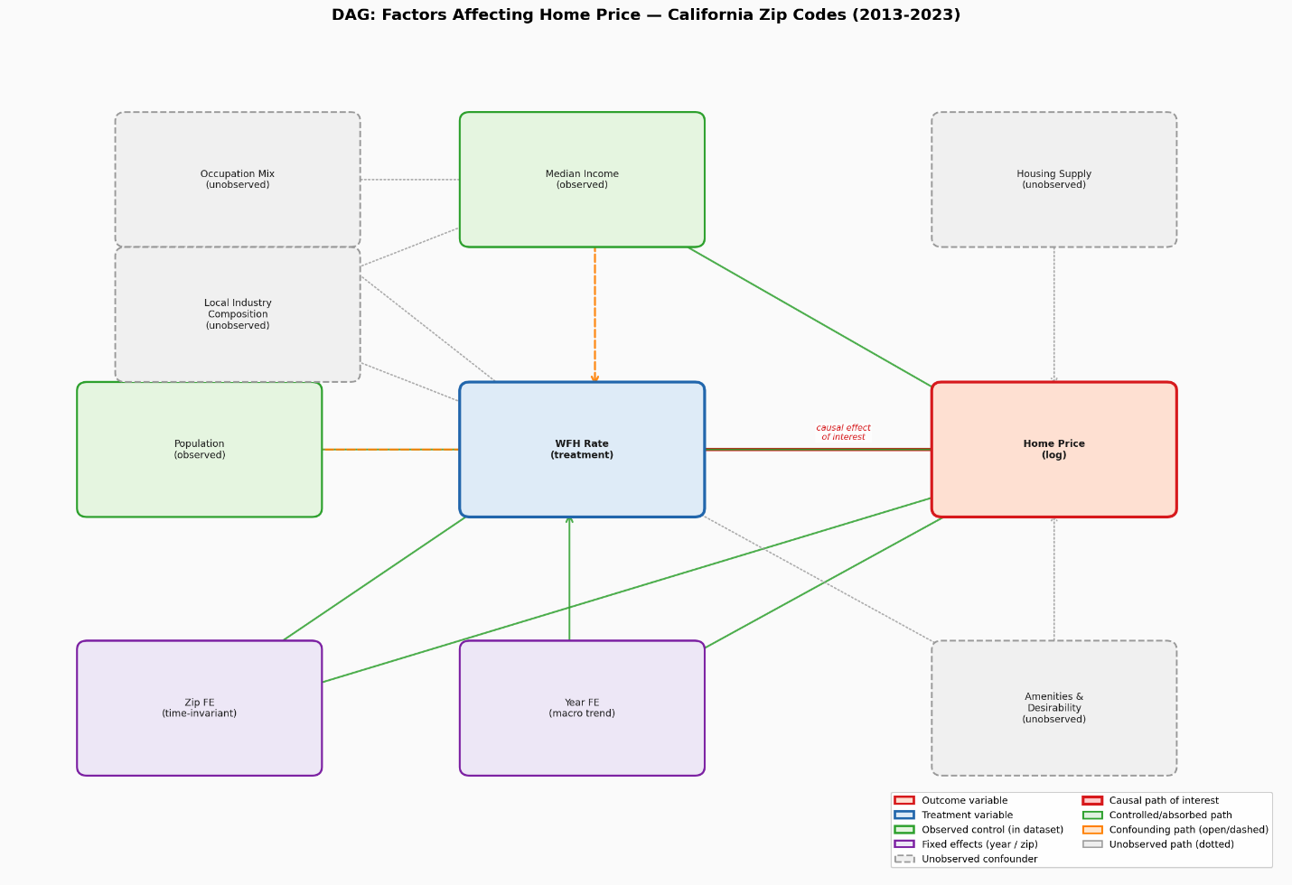
- Key model equations:
This study deploys three specifications including:
3.1 Pool-OLS:
Log_$Housing_price= α+ β_{1}*{WFH}_{it}+ β_{2}*Log_{Income}_{it}+ β_{3}*Log_{Pop}_{it}+ ε_{it}$
This specification uses all cross-sectional and time-series variation and serves as an descriptive benchmark. The estimate of β1 is expected to be upward biased due to positive selection of high-amenity, high-income zip codes into high WFH rates.
3.2 Year Fixed Effect:
$$Log_Housing_price=α+β_{1}*{WFH}_{it}+β_{2}*{{Log}_{Income}}_{it}+β_{3}*Log_{Pop}_{it}+λ_{it}+ε_{it}$$
where $λ_{it}$ represents as year fixed effects. This controls for macro shocks — including the COVID-19 demand surge, Federal Reserve interest rate cycles, and statewide housing market trends — and identifies β1 from cross-sectional variation within each year, conditional on observed controls.
3.3 Two-way Fixed Effect:
$$Log_Housin_price=α+β_{1}*{WFH}_{it}+β_{2}*Log_{Income}_{it}+β_{3}*Log_{Pop}_{it}+µ_{it}+λ_{it}+ε_{it}$$
where $µ_{it}$is a zip code fixed effect. Equation (3) is my preferred specification. The zip FE removes all observed and unobserved characteristics of a zip code that are constant over time, while year FE controls for macroeconomic shocks. The coefficient β1is identified purely from within-zip changes in WFH rates over time.
- Core Assumptions:
OLS is used as the primary estimation method in this study. Therefore, a key identifying assumption is that the error term is uncorrelated with the working-from-home variable in the current, past, and future periods. This assumption implies that the working-from-home rate is exogenous, meaning that unobserved factors affecting housing prices are not systematically related to the working-from-home variable.
- Threats to Identification and Responses
This study identifies several threats to identification. The first threat is reverse causality. Rising housing prices in a zip code may cause some residents to move out. Lower-income workers, whose jobs cannot be done from home, may leave these expensive areas. As a result, the remaining residents are more likely to work from home. This process may increase the observed share of people working from home. In this case, housing prices may affect the WFH rate, rather than WFH affecting housing prices.
To address this issue, the study uses the COVID-19 period as a natural shock. During the COVID-19 pandemic, the number of people working from home increased significantly. Therefore, this study estimates the model separately for two periods: 2013–2019 and 2020–2023. If reverse causality is the main driver, the estimated relationship between WFH and housing prices should differ across these two periods.
The second threat comes from time-invariant unobserved confounders. As shown in Specification 3, the Zip Code Fixed Effects model helps control factors that do not change over time within a zip code. However, it cannot control unobserved variables that change over time. For example, a technology company relocating to a zip code may attract remote workers while also increasing housing demand and housing prices through channels unrelated to WFH. To address this concern, NDVI (Normalized Difference Vegetation Index), which is stored on Google Earth Engine, is included as a control variable. NDVI measures the level of greenness or vegetation in an area. When more buildings or offices are constructed in a location, the level of greenness may decrease over time. Therefore, including NDVI helps control for changes in land development and local environment that may affect housing prices.
- Planned Robustness check:
Several robustness checks are conducted to verify the reliability of the results. The first check excludes imputed observations. According to the dataset summary statistics, there are 67 imputed observations. This test ensures that these imputed values do not affect the regression results. The coefficients are expected to remain unchanged because these observations fall outside the regression sample due to missing housing price or income data.
The second robustness check is a pre-period placebo test (2013–2019). This test examines whether WFH predicts housing prices before the COVID-19 pandemic, when the share of remote workers was low and relatively stable. If the causal mechanism mainly occurs after the COVID-19 shock, the estimated coefficient should be smaller and less stable during the pre-pandemic period. A larger coefficient after 2020 would support the causal interpretation.

